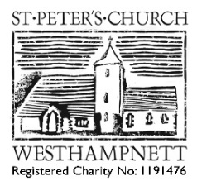
WEDDINGS AT ST PETER’S: APPLICATION FORM
The Minister of the Parish is The Reverend Rachel Hawes, Associate Rector. M: 07768875590 E: rachel.hawes@outlook.com
Date of Interview:
 | MAN | WOMAN
Full name
Address

How long have you lived at this address?
Mobile
Email
Proposed date & time of wedding

Date of birth
Age at wedding date
Occupation
Father’s full name & occupation
Mother’s full name & occupation
Have you been married before?
If you have been married before, how did the marriage end (eg death, divorce)?
If you have divorced, please supply a copy of your decree absolute.
Have you ever entered into a civil partnership?
Are you related or connected to each other by marriage?
Nationality
Please supply a copy of your passport.
Have you been baptised? If so where?
Which Qualifying Connection are you relying on?
What is your Parish Church?
Proposed witnesses to the marriage.

NOTES PAGE

